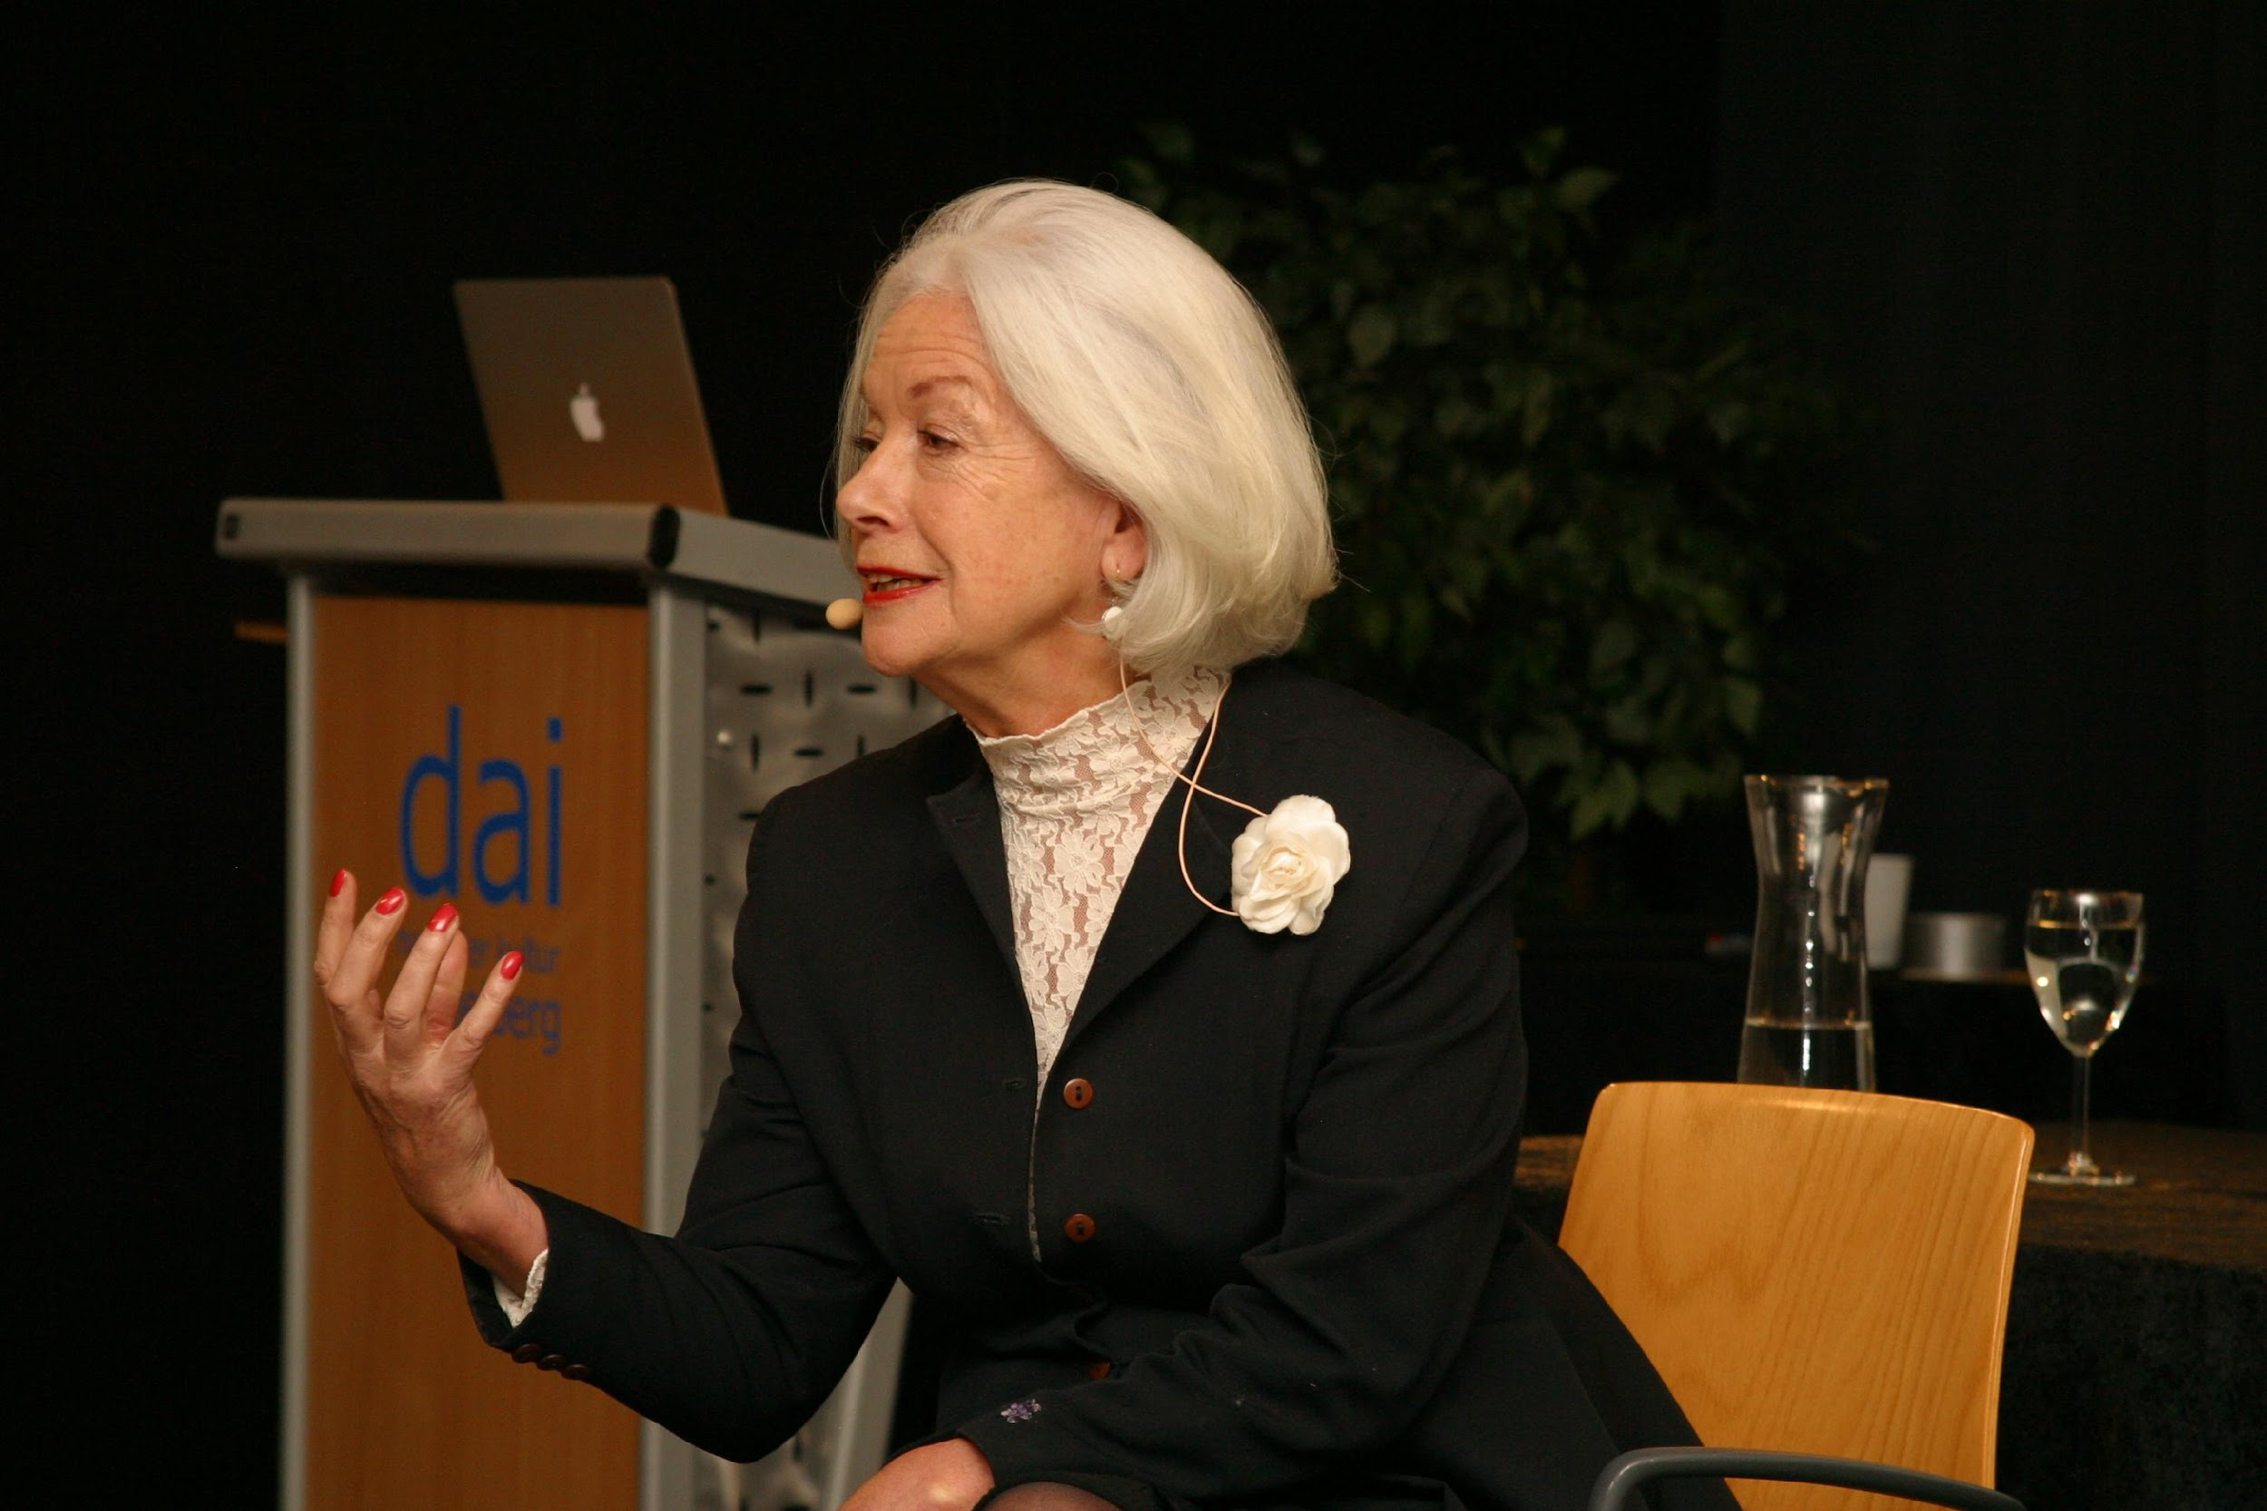
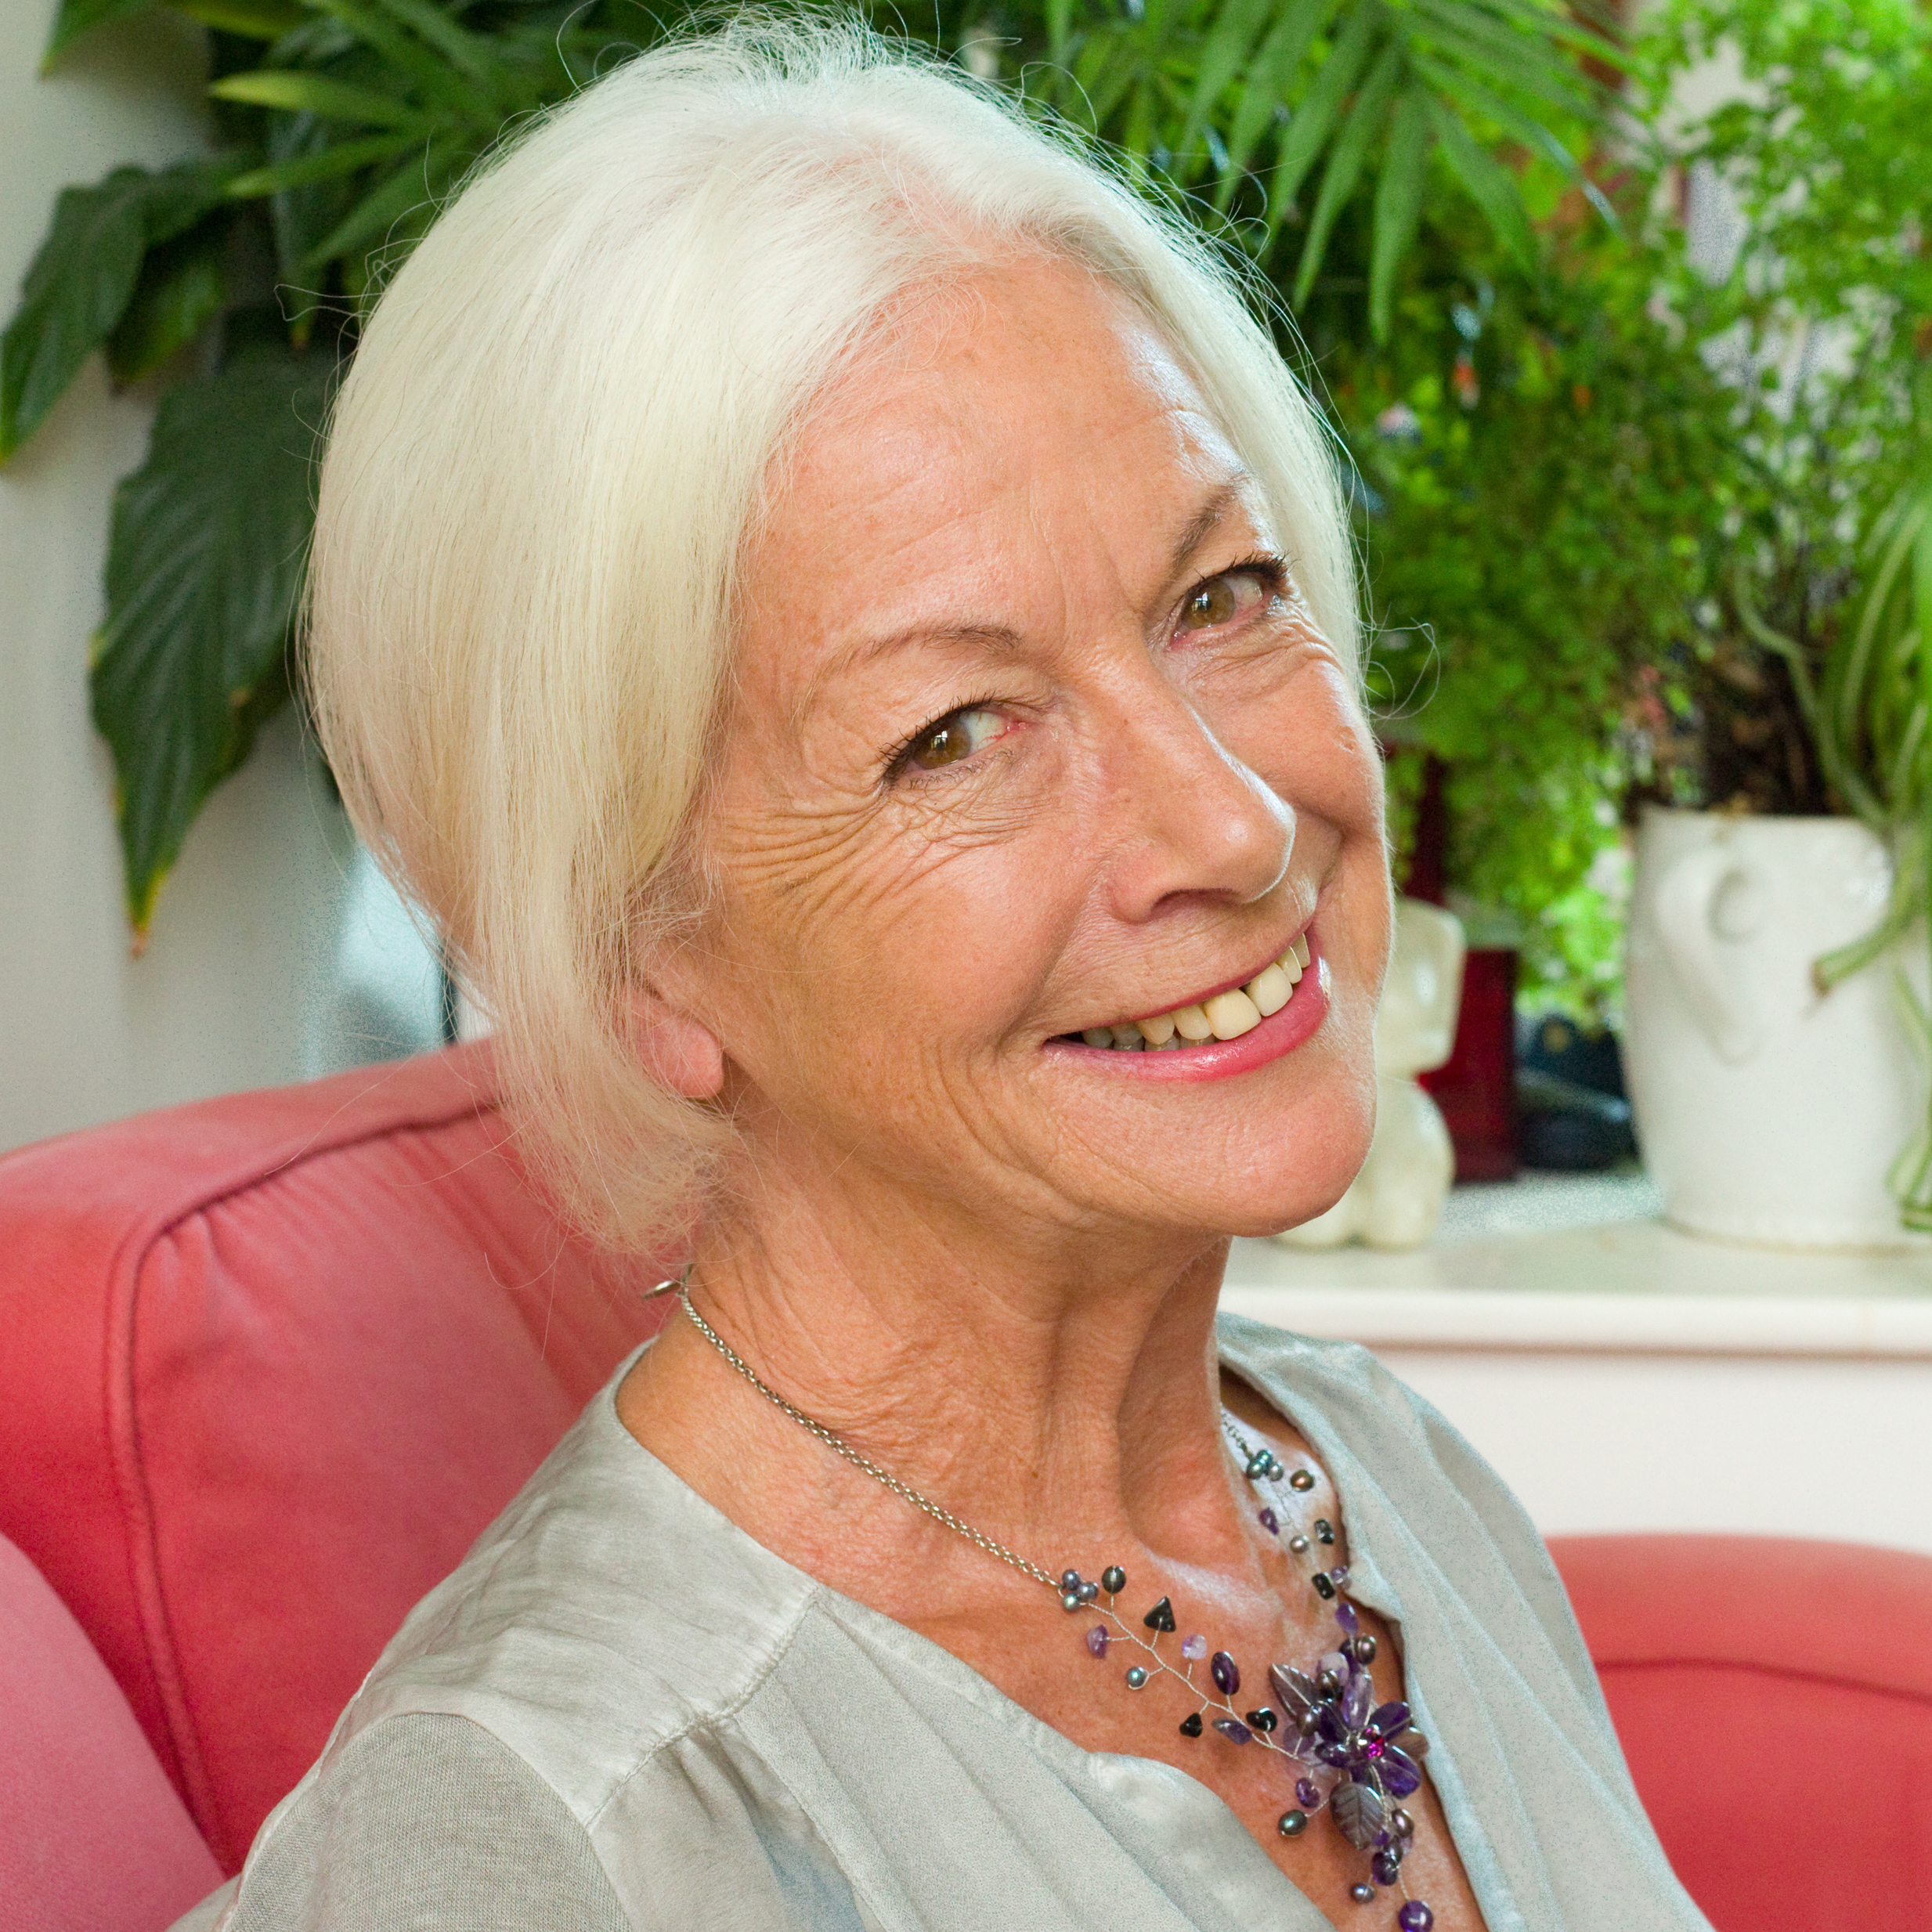

Dr Scilla Elworthy turns vision into action.
Today her full attention is on developing Business Plan for Peace, resulting from her 2017 book: The Business Plan for Peace: Building a World Without War.

She has been three times nominated for the Nobel Peace Prize for developing effective dialogue between nuclear weapons policy-makers worldwide and their critics, with the Oxford Research Group she founded in 1982. Peace Direct, voted ‘Best New Charity’ in 2005, goes from strength to strength under brilliant young leadership, founded by Scilla in 2002 to fund, promote and learn from local peace-builders in conflict areas.

Scilla was adviser to Archbishop Desmond Tutu and Sir Richard Branson in setting up ‘The Elders’, and was Awarded the Niwano Peace Prize in 2003. She co-founded Rising Women Rising World in 2013, and FemmeQ in 2016 to establish the qualities of feminine intelligence - for men as for women - as essential for building a safer world.

Her TED talk on non violence has been viewed by over 1,400,000 people on TED and YouTube. Her book Pioneering the Possible: awakened leadership for a world that works (North Atlantic Books, 2014) continues to receive critical acclaim from experts in the field.

She’s Ambassador for Peace Direct, a Councillor of the World Future Council and patron of Oxford Research Group; adviser to the Syria Campaign and the Institute for Economics and Peace. She advises the leadership of selected international corporations as well as young social entrepreneurs. Scilla is a mother, stepmother, and grandmother and loves messing about in her garden near Oxford in the UK.

www.thebusinessplanforpeace.org contact@thebusinessplanforpeace.org
www.scillaelworthy.com contact@scillaelworthy.com

