DR SCILLA ELWORTHY – KEYNOTE SPEAKER | MEDIA REQUESTS

Thank you for your email and interest in Dr Scilla Elworthy’s work. Dr Elworthy receives many requests for speaking engagements and interviews. She reserves her time for those opportunities that provide the greatest possible audience and impact. As a result, we ask that you read the information below and complete the Media/Speaker Request Form, this will help us in evaluating this opportunity and scheduling a time to connect. Once you have completed the form please send it to simon@planforpeace.org.

INTRODUCTION
“In half a century of work in the world, the most important lesson I’ve learned is that inner work is a prerequisite for outer effectiveness, for the simple reason that the quality of our awareness directly affects the quality of results produced.

The new brand of leaders that we need — those who are actually able to meet the challenges of today and thrive in the world of tomorrow — are the ones who know and live the connection between inner self-development and outer action. If we want to communicate clearly, transform conflicts, generate energy, and develop trust within our families, in our places of work or in government, our first challenge is to do the inner work.”

KEYNOTE TOPICS:

- THE MIGHTY HEART IN ACTION
Based on Dr Elworthy’s 2022 Book, this keynote takes you through the skills that are fundamentally useful in enabling us to find the energy of our own passion, to communicate effectively, to address our fears and self-doubt, to balance right- and left-brain intelligence, and to develop the presence and the inner power needed to reach out across difference. These are the skills that enable us to change the world, to build a safer world, one person at a time.

- THE BUSINESS PLAN FOR PEACE
Based on Dr Elworthy’s book The Business Plan for Peace - Building a World Without War, this keynote offers valuable and practical approaches to how businesses can include their corporate and social responsibility agenda into their mission and training for their employees. This talk can be adapted for university audiences, professional associations and conferences - wherever there is an issue about lack of communication, learning skills, team coherence, motivation or the need for inspiration. Dr Elworthy will bring insights and lessons learned about a global shift in culture away from the habit of war, towards a manifest commitment to prevent violent conflict and build sustainable peace throughout the world.
“What you taught us about real listening has enabled us to resolve in 15 minutes what would have taken four hours and still not been settled” (Global President of leading luxury & fashion house)

- FEMMEQ – THE NEW INTELLIGENCE
The emerging power of feminine intelligence, and why it’s an essential tool for men and women in future decision-making to build the future we want for ourselves and our children.
“After these two days, I am blown away, inspired and energised! Ready to change the world.” (Sue Liderth, Head of IT - Emerging Markets at ADIDAS)

- EMPOWERING GEN Z AS AGENTS OF CHANGE
Many young people are distressed and fearful about the future and frequently ask what they can do to avert catastrophe. Dr Elworthy offers a series of questions, the answers to which enable individuals to get clear about their passion, their skills and their potential contribution to a safer world.
“We have received dozens and dozens of positive responses to your speech. People were so inspired; everyone was so thankful that they could learn from your wisdom and experience. It was a great honor for the Montessori movement that you gave this keynote to our Congress.” (IMC, Prag July 2017)

PLEASE NOTE: If you would like to invite Dr Scilla Elworthy to speak at your event on one of these topics or for Dr Elworthy to create something very specific for your group, or are requesting a media interview, please complete the speaker request form below and return to simon@planforpeace.org:

Media/Speaker Request Form:

To aid in the smooth running of an event or interview please see below a number of items for you to complete:

- Are you requesting an interview with Scilla or for her to attend an event as a Keynote Speaker?

- What is the name of the organisation running the event/interview? Please provide name and contact details of the presenter/interviewer/organiser?

- What is the date of the interview/event and the location where it will take place?

- What would you like Scilla to talk about? Please provide three questions would you like to ask Scilla?

- How many people at the event or on your mailing list/network will the interview/event reach?

- Please give a rough profile of the recipients e.g. business? government? NGO? peace communities? college? etc.

- Will the keynote talk/interview be video or voice recording? Please note the organiser must take full responsibility for the tech arrangements for any online interviews, video and voice recordings.

- In the case of an interview, when is it to be broadcast/published?

- Will the event/recording be made available at a charge or free of charge?

- Are you offering a fee for Scilla’s time to prepare, travel and present at the event/interview? Will you cover any travel expenses if applicable?

- We request that you show details of Scilla’s latest book the Mighty Heart in Action and website (www.thebusinessplanforpeace.org) at the end of the event/interview.

- Please note that Scilla is asked to do so many interviews and events that it is not possible to publicise every one through her network.

Please complete and return to simon@planforpeace.org
Dr Scilla Elworthy - Biography

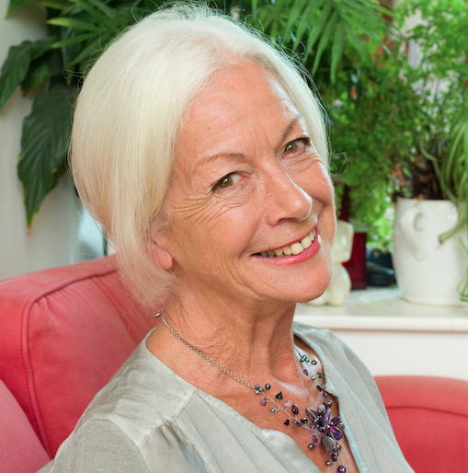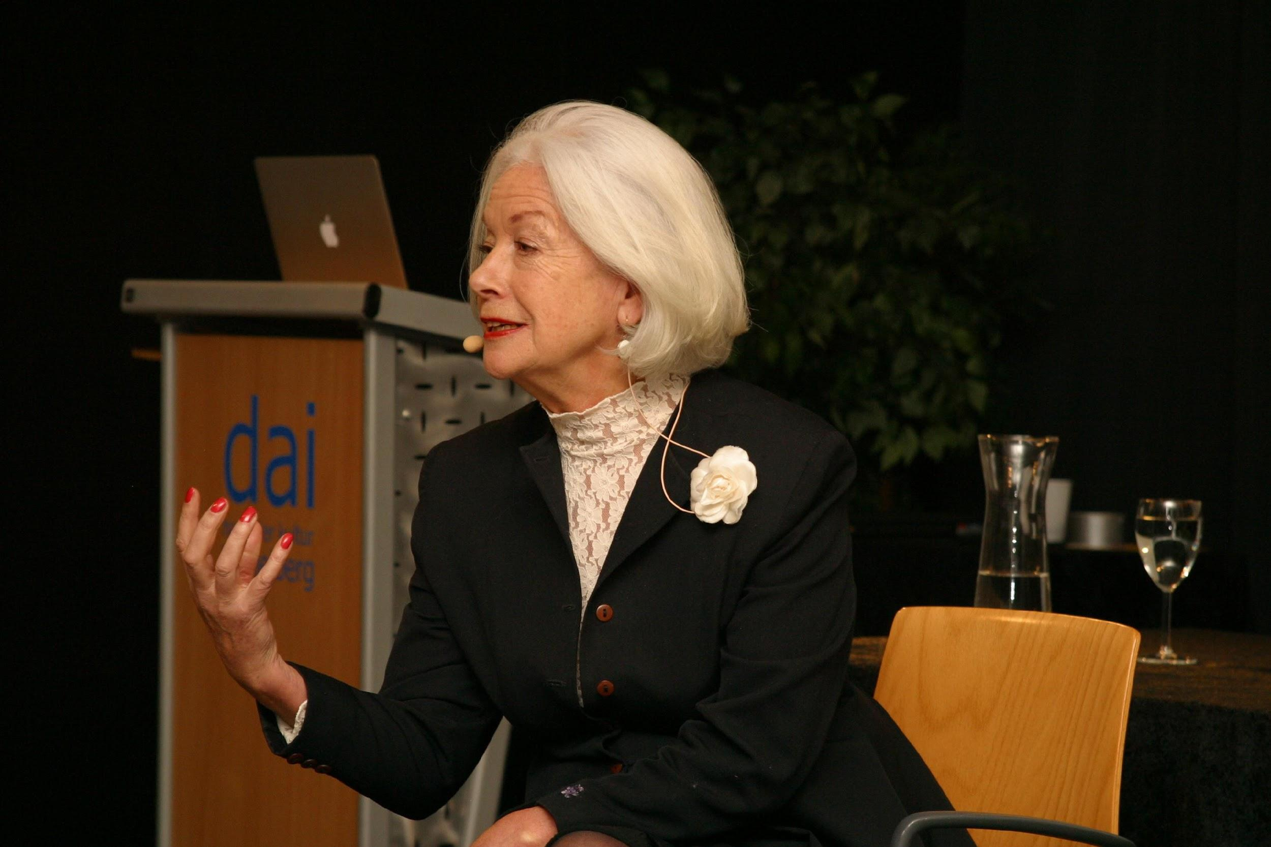

Three times Nobel Peace Prize nominee for her work with Oxford Research Group to develop effective dialogue between nuclear weapons policy-makers worldwide and their critics. She now leads The Business Plan for Peace to help prevent violent conflict and build sustainable peace throughout the world, because it is possible; based on her latest books The Business Plan for Peace: Building a World Without War (2017), The Mighty Heart: how to transform conflict (2020), and The Mighty Heart in Action (2022).
Scilla founded Peace Direct in 2002 to fund, promote and learn from local peace-builders in conflict areas, was awarded the Niwano Peace Prize in 2003 and advised Peter Gabriel, Archbishop Desmond Tutu and Sir Richard Branson in setting up ‘The Elders’. Her TED talk on nonviolence has been viewed by over 1,500,000 people.

contact@planforpeace.org

